THIRD EYE OF THE BLIND

Most of the people have different diseases, there are those who don’t walk, those who don’t talk, who don’t listen there are different diseases but there are some ways of helping people with those disabilities so that’s why I got an inspiration of how we can help people with problem especially when there are at home or any other places that they need to do different activities using their hands cause most of the time they are not able to do it due not being able to handle those stuff and also their white cane, in order to help them I thought about making some help for them which is called THIRD EYE OF THE EYE.

During the process of implementing it I used different materials like Arduino UNO Board, buzzer, led, ultrasonic sensor, I used few materials so that it won’t have high weight and be big for wearing it and being able to do different activities. During my project I installed in it a led probably you can ask why we put their a led for people who are not able to see anything, but it will help people who are near them it might not have seen the obstacle but due to the light they get the notification

ADVANTAGES OF USING THIRD EYE OF THE BLIND

* It will help them to do other activities like holding something
* It will be easier for them to know that there is an obstacle in front of them
* Buzzer which is their will help them in case there are not even able to talk so after hearing the sound people there can give help
* It is simple and cheap
* There are no complications in using it.

Even though the white cane is important for them but also this third eye for the blind will help them that much.

**PROGRAMMING CODE**

**// defines pins numbers**

**const int trigPin = 9;**

**const int echoPin = 10;**

**const int buzzer = 11;**

**const int ledPin = 13;**

**// defines variables**

**long duration;**

**int distance;**

**int safetyDistance;**

**void setup() {**

**pinMode(trigPin, OUTPUT); // Sets the trigPin as an Output**

**pinMode(echoPin, INPUT); // Sets the echoPin as an Input**

**pinMode(buzzer, OUTPUT);**

**pinMode(ledPin, OUTPUT);**

**Serial.begin(9600); // Starts the serial communication**

**}**

**void loop() {**

**// Clears the trigPin**

**digitalWrite(trigPin, LOW);**

**delayMicroseconds(2);**

**// Sets the trigPin on HIGH state for 10 micro seconds**

**digitalWrite(trigPin, HIGH);**

**delayMicroseconds(10);**

**digitalWrite(trigPin, LOW);**

**// Reads the echoPin, returns the sound wave travel time in microseconds**

**duration = pulseIn(echoPin, HIGH);**

**// Calculating the distance**

**distance= duration*0.034/2;**

**safetyDistance = distance;**

**if (safetyDistance <= 5){**

**digitalWrite(buzzer, HIGH);**

**digitalWrite(ledPin, HIGH);**

**}**

**else{**

**digitalWrite(buzzer, LOW);**

**digitalWrite(ledPin, LOW);**

**}**

**// Prints the distance on the Serial Monitor**

**Serial.print("Distance: ");**

**Serial.println(distance);**

**}**

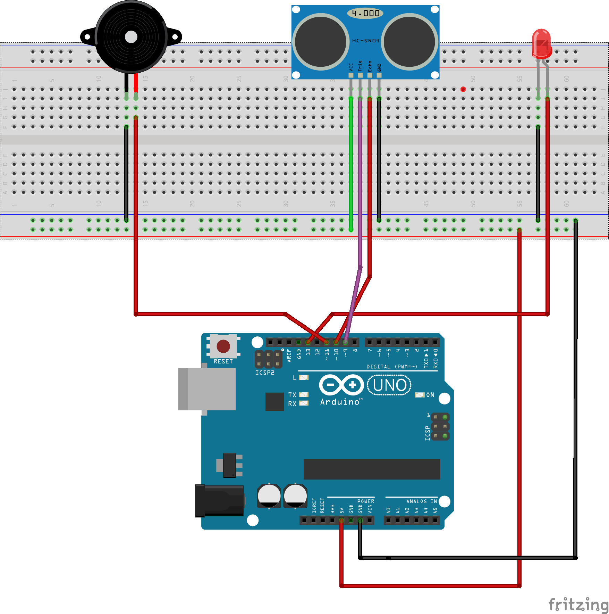

**The link about the video**

https://youtu.be/j8sz97xxP20